Genetics

# linkage and genetic mapping in eukaryotes

## Morgan and the discovery of linkage

If genes on different chromosomes assort independently because nonhomologous chromosomes align independently on the spindle during meiosis I, how do genes on the same chromosome assort?

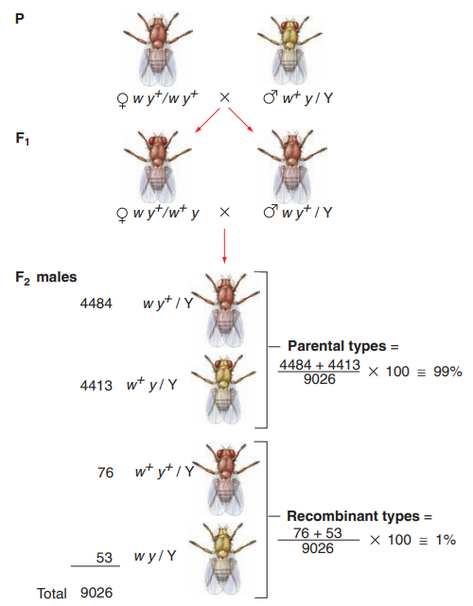Morgan investigated several traits linked to the X chromosome in Drosophila: for example, eye and body color.

For the eye color, the dominant wild-type allele w⁺ specifies red eyes, while the

recessive mutant allele w confers white eyes. The alleles of the yellow body color gene are y⁺ (the dominant wild-type allele for brown bodies) and y (the recessive

mutant allele for yellow bodies).

Pay attention to the slash symbol (/), which is used to separate genes found on chromosomes of a pair (either the X and Y chromosomes as in this case, or a pair of X chromosomes or homologous autosomes).

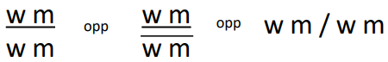Examples:

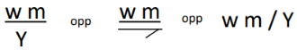- w and m alleles are on the same chromosome

- w and m alleles are on the X chromosome in a male

In a cross between a female with mutant white eyes and a wild-type brown body (w y⁺ / w y⁺) and a male with wild-type red eyes and a mutant yellow body (w⁺ y / Y), the F₁ offspring are evenly divided between brown-bodied females with normal red eyes (w y⁺ / w⁺ y) and brown-bodied males with mutant white eyes (w y⁺ / Y).

Note that the male progeny looks like their mother because their phenotype directly reflects the genotype of the single X chromosome they received from her. The same is not true for the F₁ females, who received w y⁺ on the X from their mother and w⁺ y on the X from their father.

These F₁ females are thus dihybrids: with two alleles for each X-linked gene, one derived from each parent, the dominance relations of each pair of alleles determine the female phenotype.

Now comes the significant cross for answering our question about the assortment of genes on the same chromosome.

If these two Drosophila genes for eye and body color assort independently, as predicted by Mendel’s second law, the dihybrid F₁ females should make four kinds of gametes, with four different combinations of genes on the X chromosome and an equal frequency — ¼ w y⁺, ¼ w⁺ y, ¼ w⁺ y⁺, and ¼ w y.

If it happens this way, approximately half of the gametes will be of the two parental types, carrying either the w y⁺ allele combination seen in the original female of the P generation or the w⁺ y allele combination seen in the original male of the P generation. The remaining half of the gametes will be of two recombinant types, in which reshuffling has produced either w⁺ y⁺ or w y allele combinations not seen in the P generation parents of the F₁ females.

But of the total 9026 male flies counted, almost 99% had parental genotype, while the new combinations w⁺ y⁺ and w y made up little more than 1% of the total.

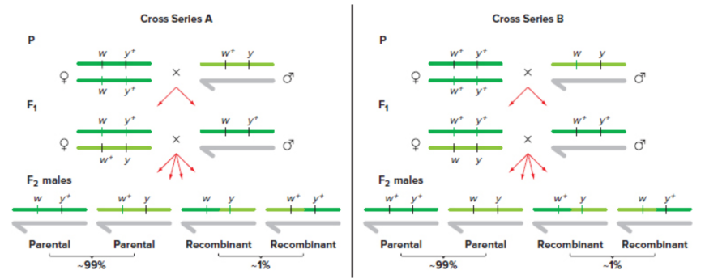We can explain why the two genes fail to assort independently in one of two ways. Either the w y⁺ and w⁺ y combinations are preferred because of some intrinsic chemical affinity between these particular alleles, or it is the parental combination of alleles the F₁ female receives from one or the other of her P generation parents that shows up most frequently.

A second set of crosses involving the same genes but with a different arrangement of alleles explains why the dihybrid F₁ females do not produce a 1:1:1:1 ratio of the four possible types of gametes. In this second set of crosses, the original parental generation consists of red-eyed, brown-bodied females (w⁺ y⁺ / w⁺ y⁺) and white-eyed, yellow-bodied males (w y / Y), and the resultant F₁ females are all w⁺ y⁺ / w y dihybrids. This time, w⁺ y / Y and w y⁺ / Y are the recombinants that account for little more than 1% of the total, while w y / Y and w⁺ y⁺ / Y are the parental combinations, which again add up to almost 99%. You can see that there is no preferred association of w⁺ and y or of y⁺ and w in this cross. Instead, a comparison of the two experiments with these X chromosome genes demonstrates that the observed frequencies of the various types of progenies depend on how the arrangement of alleles in the F₁ females originated.

Note that in both experiments, it is the parental classes —the combinations originally present in the P generation—that show up most frequently in the F₂ generation, while the recombinant classes occur less frequently.

When genes assort independently, the numbers of parental and recombinant F₂ progeny are equal, because a doubly heterozygous F₁ individual produces an equal number of all four types of gametes. By comparison, two genes are considered linked when the number of F₂ progeny with parental genotypes exceeds the number of F₂ progeny with recombinant genotypes. Instead of assorting independently, the genes behave as if they are connected to each other much of the time. The genes for eye and body color are so tightly coupled that the parental combinations of alleles are reshuffled to form recombinants in only 1 out of every 100 gametes formed. In other words, the two parental allele combinations of these tightly linked genes are inherited together 99 times out of 100.

Linkage is not always this tight. In Drosophila, a mutation for miniature wings (m) is also found on the X chromosome. A cross of red-eyed females with normal wings (w⁺ m⁺ / w⁺ m⁺) and white-eyed males with miniature wings (w m / Y) yields an F₁ generation containing all red-eyed, normal-winged flies (w⁺ m⁺ / w m and w⁺ m⁺ / Y). Of the F₂ males, 67.2% are parental types, while the remaining 32.8% are recombinants. This preponderance of parental combinations among the F₂ genotypes reveals that the two genes are linked: the parental combinations of alleles travel together more often than not. But compared to the 99% linkage between the w and y genes for eye color and body color, the linkage of w to m is not that tight.

Linkage is not restricted to X chromosome. Morgan observed again fruit flies, that carry an autosomal gene for body color (in addition to the X-linked y gene); the wild type is once again brown, but a recessive mutation in this gene gives rise to black (b). the second bene he considered on the same autosome helps determine the shape of a fruit fly’s wing, with the wild type that produces normal wings and a recessive mutation (vg) producing vestigial wings.

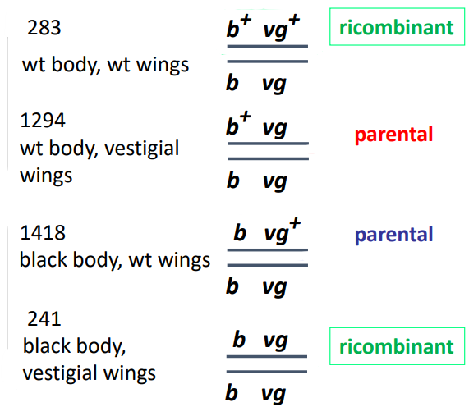He crossed black-bodied females with normal wings (b vg⁺ / b vg⁺) and brown-bodied males with vestigial wings (b⁺ vg / b⁺ vg). All the F₁ generation are double heterozygotes (b⁺ vg / b vg⁺). Then he performed a testcross, that is the best approach to study linkage, in which he crossed the double heterozygotes with a recessive tester (double recessive – black body and vestigial wings b vg/ b vg). The phenotypes of the offspring thus indicate the kinds of gametes received from the mother.

If the two genes are segregating independently, the expected result of the testcross is:

* ¼ b⁺ vg⁺ / b vg
* ¼ b⁺ vg / b vg
* ¼ b vg⁺ / b vg
* ¼ b vg / b vg

But roughly 84% of the testcross progeny in one experiment received parental gene combinations (that is, allelic combinations transmitted into the F₁ females by the gametes of each of her parents), while the remaining 16% were recombinants. Because the parental classes outnumbered the recombinant classes, we can conclude that the autosomal genes for black body and curved wings are linked.

Morgan’s observations:

* The parental phenotypic classes were the most frequent, and the recombinant classes occurred less frequently
* Each of the two parental classes have approximately equal numbers, as well as each of the two recombinant classes have approximately equal numbers
* The percentage of recombinants varies according to the gene pairs analyzed
* The frequency of recombination is independent of the arrangement of alleles

## recombination

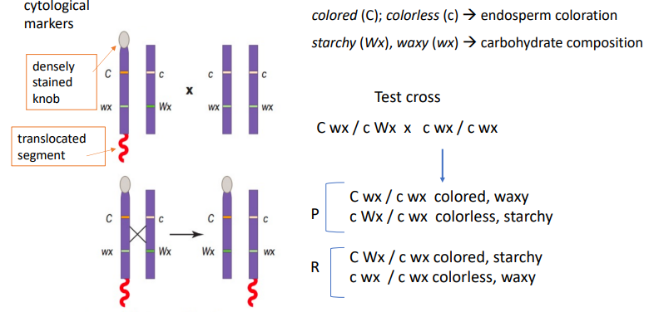Morgan suggested that the chiasmata observed were sites of chromosome breakage and exchange resulting in genetic recombination. Morgan’s idea that the physical breaking and rejoining of chromosomes during meiosis was the basis of genetic recombination seemed reasonable. But there was not any evidence that crossing-over between homologous chromosomes actually occurs until the identification of physical markers, or cytologically visible abnormalities that make it possible to keep track of specific chromosome parts from one generation to the next, that enabled researchers to turn the logical deductions about recombination into facts derived from experimental evidence. In 1931, Harriet Creighton and Barbara McClintock published the results of experiments showing that genetic recombination indeed depends on the reciprocal exchange of parts between maternal and paternal chromosomes.

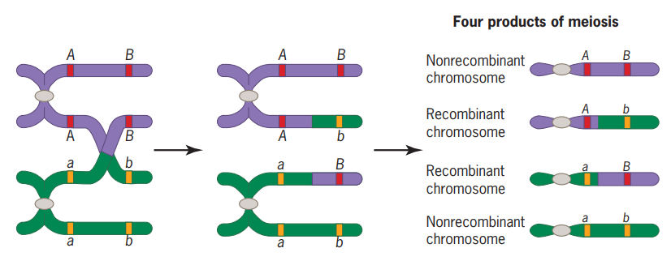Thomas Hunt Morgan’s belief that chiasmata represent sites of physical crossing-over between chromosomes and that such crossing-over may result in recombination, led him to the following logical deduction: different gene pairs exhibit different linkage frequencies because genes are arranged in a line along a chromosome. The closer together two genes are on the chromosome, the less their chance of being separated by an event that cuts and recombines the line of genes. To look at it another way, if we assume for the moment that chiasmata can form anywhere along a chromosome with equal likelihood, then the probability of a crossover occurring between two genes increases with

Morgan’s conclusions:

* Genes were considered as “beads on a string”
* During meiosis genes that are close to each other on a chromosome will often segregate together 🡪 genetic linkage
* Recombinants are due to crossing-over between homologous chromosome during meiosis. Crossing-over is a reciprocal exchange of genetic material, therefore the two recombinant classes have similar frequencies to each other
* The chiasmata represent points of genetic exchange between chromosomes at meiosis
* The closer two genes are, the less likely that a crossing-over will occur between them. The frequency of recombination is related to the distance between the genes on a chromosome.

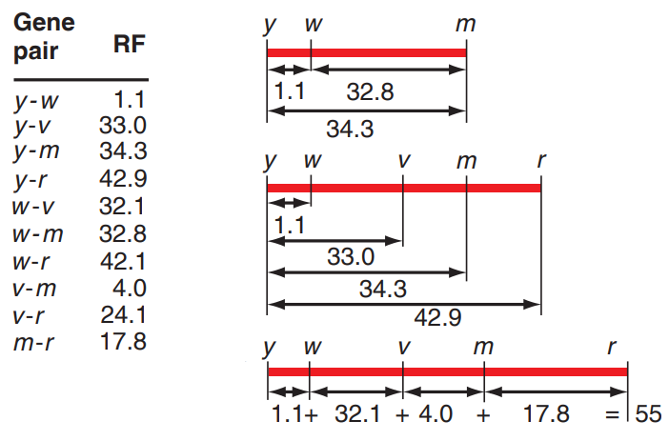One of Morgan’s students, Alfred H. Sturtevant, proposed that the percentage of total progeny that were recombinant types, the recombination frequency (RF), could be used as a quantitative measure of the distance between two genes/loci along the chromosome. The centimorgan (cM) is the unit of genetic distance representing 1% recombination frequency between two loci. Mappers often refer to a centimorgan as a map unit (m.u.).

Sturtevant asked whether data obtained from a large number of two-point crosses (crosses tracing two genes at a time) would support the idea that genes form a definite linear series along a chromosome. Sturtevant began by looking at X-linked genes in Drosophila. By checking the data for every combination of three genes, you can assure yourself that this ordering makes sense (example: because the distance between y and m is greater than the distance between w and m, the order of genes must be y-w-m). Moreover, the left-to-right orientation is arbitrary; the map of the example would be equally correct if it portrayed y on the right and r on the left. The fact that the recombination data yield a simple linear map of gene position supports the idea that genes reside in a unique linear order along a chromosome.

The definition of linkage states that the proportion of recombinant classes is smaller than that of parental classes, thus a recombination frequency of less than 50% indicates linkage that could be:

* complete linkage 🡪 recombination frequency = 0
* partial linkage 🡪 0 < recombination frequency < 0,5

But what can give rise to a recombination frequency of 50%? We already know the situation in which two genes are located on different (= nonhomologous) chromosomes. They will obey Mendel’s law of independent assortment for two reasons:

* 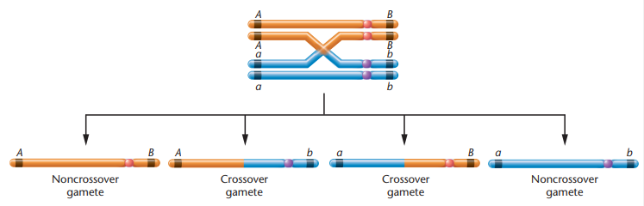the two chromosomes can line up on the spindle during meiosis I in either of two equally likely configurations. As a result, when summed over the products of many meiosis, the number of parental and recombinant gametes will be equal
* if a crossover occurs between any one gene and the centromere, that meiosis will produce two parental and two recombinant gametes. Thus, if A and B are on nonhomologous chromosomes, a dihybrid will produce all four possible types of gametes with approximately equal frequency.

But experiments have established that genes located very far apart on the same chromosome also show recombination frequencies of approximately 50%.

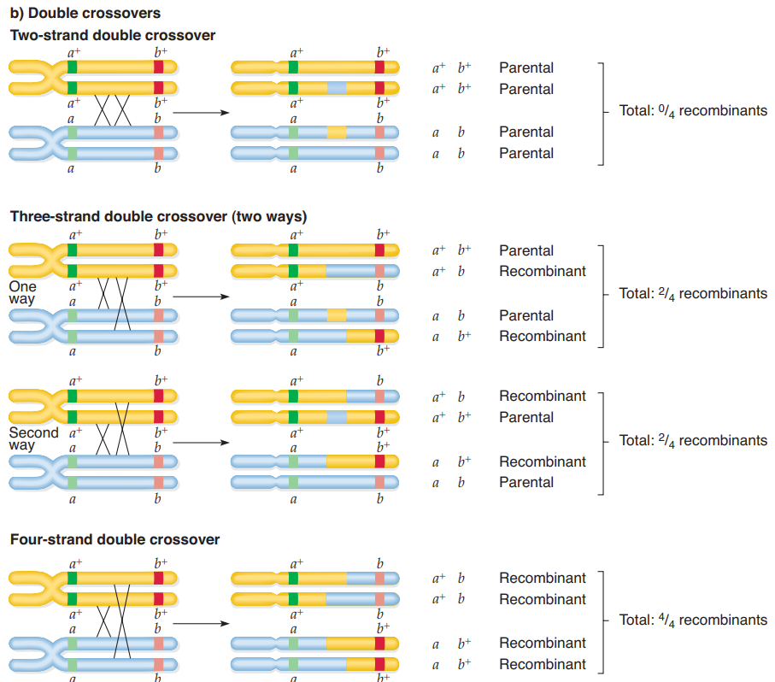When two genes are very close to each other on the same chromosome, only two kinds of meioses are likely to occur: those with no crossovers (NCO) and rare meiosis with a single crossover (SCO). An NCO meiosis yields only parental gametes, while an SCO event produces 50% recombinant gametes.

When two genes are farther apart, SCOs are more frequent, and in some meioses, two crossovers between A and B can also occur (DCO meiosis). DCO meioses can be one of four different types: two, three, or all four nonsister chromatids may cross over (three chromatids could participate in DCOs in two ways). Because the four DCO events are equally frequently, the average fraction of recombinant gametes produced by DCOs is 50%.

$$mean=\frac{0\%+50\%+50\%+100\%}{4}=50\% R$$

The same is true for triple crossover events, quadruple crossover events etc.

Thus, even if the two genes are far enough apart on the same chromosome that at least one crossover occurs between them in every meiosis, the pool of gametes produced by a dihybrid would be only 50% recombinant types.

In conclusion, only in the absence of multiple crossing-over between two loci would there be a linear relationship between map distance and recombination frequency.

## three point mapping

Mapping function: mathematical relation between the genetic distance across an interval in map units (centimorgans) and the observed frequency of recombination across the interval.

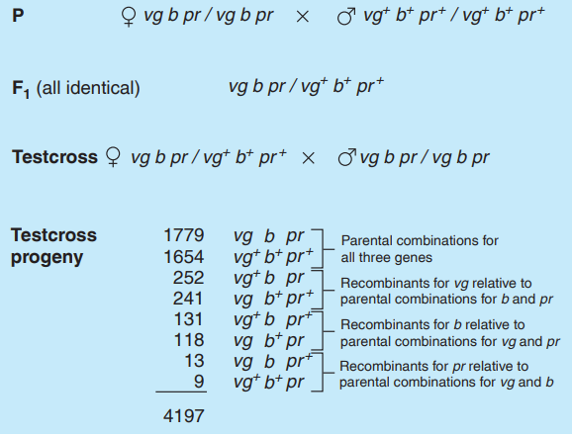The simultaneous analysis of three markers makes it possible to obtain enough information to position the three genes in relation to each other from just one set of crosses. To describe this procedure, we look at three genes linked on one of Drosophila’s autosomes. A homozygous female with mutations for vestigial wings (vg), black body (b), and purple eye color (pr) was mated to a wild-type male (in Drosophila crossing over occurs only in females’ meiosis). All the triply heterozygous F₁ progeny had normal phenotypes for the three characteristics, indicating that the mutations are autosomal recessive. In a testcross of the F₁ females with males having vestigial wings, black body, and purple eyes, the progeny was of eight different phenotypes reflecting eight different genotypes (remember that we do not know the gene order yet).

In the picture there are the results of this crossing.

In analyzing the data, we look at two genes at a time, because recombination frequency is always a function of a pair of genes. For the pair vg and b, the parental combinations are vg b and vg⁺ b⁺. To determine whether a particular class of progeny is parental or recombinant for vg and b, we do not care whether the flies are pr or pr⁺. Thus, to the nearest tenth of a map unit, the distance between vg and b, calculated as the percentage of recombinants in the total number of progeny, is:

$$\frac{252+241+131+118}{4197}×100=17,7 m.u.$$

Similarly, the distance between vg and pr is:

$$\frac{252+241+13+9}{4197}×100=12,3 m.u.$$

And the distance between b and pr is:

$$\frac{131+118+13+9}{4197}×100=6,4 m.u.$$

These calculations show that vg and b separated by the largest distance and must therefore be the outside gene. In conclusion, the genes order is vg pr b.

But the distance separating vg and b does not equal the sum of the two intervening distances. Knowing the gene order, a close examination of the chromosomes reveals the kinds of crossovers that must have occurred to generate the classes and numbers of progeny observed.

Recall that the progeny from the testcross performed earlier:

* 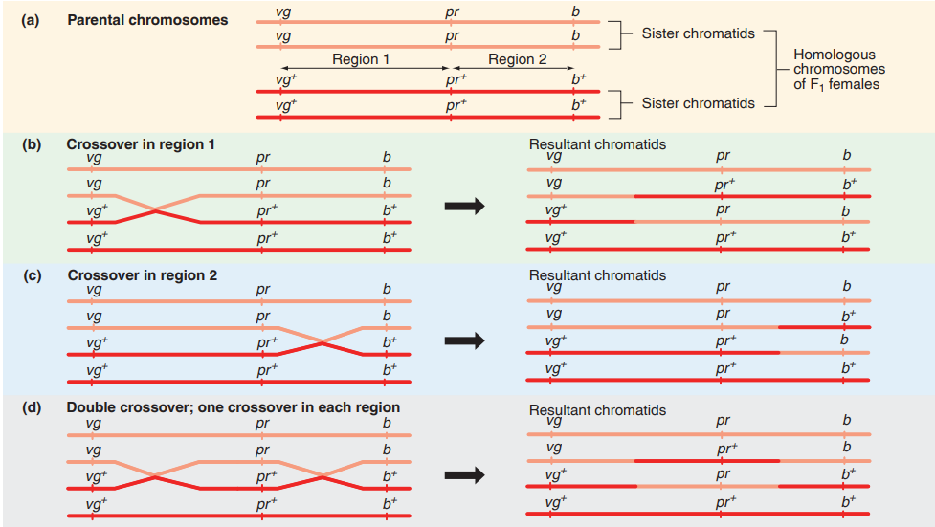Flies in the two largest groups carry the same configurations of genes as did their grandparents of the P generation: vg b pr and vg⁺ b⁺ pr⁺; they thus represent the parental classes.
* The next two group, vg⁺ b pr and vg b⁺ pr⁺, are composed of recombinants that must be the reciprocal products of a crossover in region 1 between vg and pr.
* The two groups containing vg⁺ b pr⁺ and vg b⁺ pr flies must have resulted from recombination in region 2 between pr and b.
* But what about the two smallest groups made up of rare vg b pr⁺ and vg⁺ b⁺ pr recombinants? Most likely, they result from two different crossover events occurring simultaneously, one in region 1, the other in region 2. The gametes produced by such double crossovers still have the parental configuration for the outside genes vg and b, even though not one but two exchanges must have occurred.

Indeed, it is because of the existence of double crossovers that the distance of 17.7 m.u. between vg and b calculated before does not reflect all the recombination events producing the gametes that gave rise to the observed progeny. To correct for this oversight, it is necessary to adjust the recombination frequency by adding the double crossovers twice, because each individual in the double crossover groups is the result of two exchanges between vg and b.

Therefore, the corrected distance is:

$$\frac{252+241+131+118+13+13+9+9}{4197}=18,7 m.u.$$

This value makes sense because you have accounted for all of the crossovers that occur in region 1 as well as all of the crossovers in region 2. As a result, the corrected value of 18.7 m.u. for the distance between vg and b is now exactly the same as the sum of the distances between vg and pr and between pr and b.

General rule to calculate distances:

* 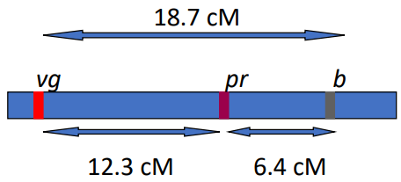Distance between vg and pr
$$\frac{single c.o. vg-pr+double c.o.}{total}×100$$

* Distance between pr and b
$$\frac{single c.o. b-pr+double c.o.}{total}×100$$

* Distance between vg and b

$$\frac{single c.o. vg-pr+single c.o. b-pr+double c.o.×2}{total}×100$$

N.B. It is possible to use the composition of alleles in these double crossover classes to determine which of the three genes lies in the middle, even without calculating any recombination frequencies. Consider again the progeny of a three-point testcross. The F₁ females are vg pr b / vg⁺ pr⁺ b⁺. Testcross progeny resulting from double crossovers in the trihybrid females of the F₁ generation received gametes from their mothers carrying the allelic combinations vg pr⁺ b and vg⁺ pr b⁺. In these individuals, the alleles of the vg and b genes retain their parental associations (vg b and vg⁺ b⁺), while the pr gene has recombined with respect to both the other genes (pr b⁺ and pr⁺ b; vg pr⁺ and vg⁺ pr). In those gametes formed by double crossovers, the gene whose alleles have recombined relative to the parental configurations of the other two genes must be the one in the middle.

In a three-point cross following three linked genes, the two parental classes contain the largest number of progeny, while the two double recombinant classes, resulting from double crossovers, are always the smallest. We can understand why double-crossover progeny are the rarest by looking at the probability of their occurrence. If an exchange in region 1 of a chromosome does not affect the probability of an exchange in region 2, the probability that both will occur simultaneously is the product of their separate probabilities. In our case the probability of a single crossover between vg and pr is 0.123 (corresponding to 12.3 m.u.), and the probability of a single crossover between pr and b is 0.064 (6.4 m.u.):

$$probability of doblue c.o. =single c.o. vg-pr×single c.o.pr-b=0,123×0,064=0,0079=0,79\%$$

The numerical frequencies of observed double crossovers, however, almost never coincide with expectations derived from the product rule. The observed proportion of double crossover is indeed:

$$\frac{double c.o.}{total}=\frac{13+9}{4197}×100=0,52\%$$

The fact that the number of observed double crossovers is less than the number expected if the two exchanges are independent events suggests that the occurrence of one crossover reduces the likelihood that another crossover will occur in an adjacent part of the chromosome. The inhibition of further crossover events by a crossover event in a nearby region of the chromosome is called chromosomal interference (crossovers not occurring independently).

Interference is not uniform and may vary even for different regions of the same chromosome. We can obtain a quantitative measure of the amount of interference in different chromosomal intervals by first calculating a coefficient of coincidence, defined as the ratio between the actual frequency of double crossovers observed in an experiment and the number of double crossovers expected based on independent probabilities:

$$coefficient of coincidence \left(C\right)=\frac{observed number of DCO}{expected number of DCO}=\frac{0,52}{0,79}=0,66$$

The definition of interference itself is:

$$interference \left(I\right)=1-coefficient of coincidence=0,34$$

If interference is 0, the frequency of observed double crossovers equals expectations, and crossovers in adjacent regions of a chromosome occur independently of each other. If interference is complete (when I=1), no double crossovers occur in the experimental progeny because one exchange effectively prevents another.

The actual physical distances between genes does not always show a direct correspondence to genetic map distances.

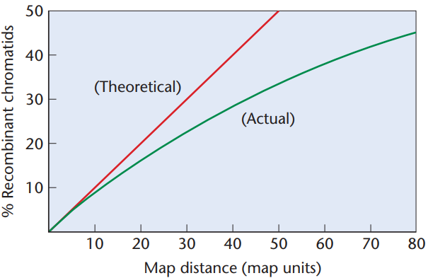When two genes are close, DCOs are not significant because the probability of their occurring is so small. However, when two genes are far apart, double and multiple crossover can occur often enough to affect the relationship between recombination frequency and map distance (= one-half the average number of crossovers expressed into percentages).

This relationship cannot be linear because no matter how far apart two genes are on a long chromosome, they will never recombine more than 50% of the time.

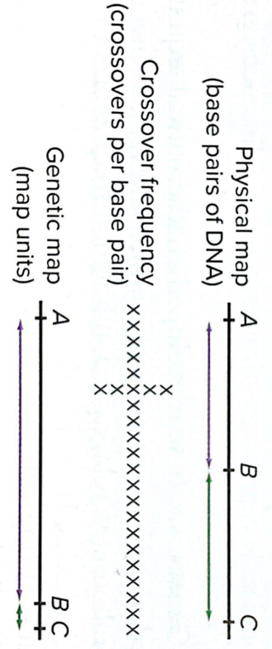Only one of the four DCOs (4-strand) preserve the linear relationship between crossovers and recombinant gametes: two crossovers occur in a 4-strand DCO and four recombinant gametes (2 crossovers : 4 recombinants). The other three types of DCOs result in fewer than four recombinant gametes.

So, the two graphs are nearly identical for distances of 5 m.u. or less; at a genetic distance this small, the RF seen in a two-point cross is an accurate measure of the physical distance. The two graphs then diverge increasingly from each other, so the RF becomes a less precise estimate at genetic distances greater than 5 m.u.

Although we have been assuming thus far that crossovers are equally likely to occur anywhere along a chromosome, recombination is not random. In human DNA, for example, most crossovers take place in so-called recombination hotspot, small regions of DNA where the frequency of recombination is much higher than average. Genes with hotspots between them (A and B) will be more distant from each other on a genetic map than another gene pair (B and C) without a hotspot between them, even though the physical distance separating each gene pair is the same. As hotspots are relatively frequent, recombination frequency is nevertheless a reasonable estimation of physical distance between most gene.

Moreover, as we said before, the combination rate is not uniform along the chromosome (in general, crossing-over is less frequent in regions of heterochromatin, and more frequent in sub-telomeric regions), and the frequency of recombination differs between species and sexes, for example in Drosophila there is no recombination in males and in human the recombination rate is higher in females.

# dna as the genetic material

## experimental evidences

In 1869, Friedrich Miescher extracted a weakly acidic, phosphorus-rich material from the nuclei of human white blood cells and named it “nuclein”. It was unlike any previously reported chemical compound, and its major component turned out to be DNA, although it also contained some contaminants.

The full chemical name of DNA is deoxyribonucleic acid, reflecting three characteristics of the substance: one of its constituents is a sugar known as deoxyribose; it is found mainly in cell nuclei; and it is acidic.

After purifying DNA from the nuclein, researchers established that it contains only four distinct chemical building blocks linked in a long chain. The four individual chemicals belong to a class of compounds known as nucleotides, that consists of a sugar with an attached base and phosphate.

A procedure than reported that DNA is localized almost exclusively within chromosomes. However, the finding that DNA is a component of chromosomes does not prove by itself that the molecule has anything to do with genes. Typical eukaryotic chromosomes also contain an even greater amount of protein. Because proteins are built of 20 different amino acids whereas DNA carries just four building block subunits, many researchers thought proteins had greater potential for diversity and were better suited to serve as the genetic material. These same scientists assumed that even though DNA was an important part of chromosome structure, it was too simple to specify the complexity of genes.

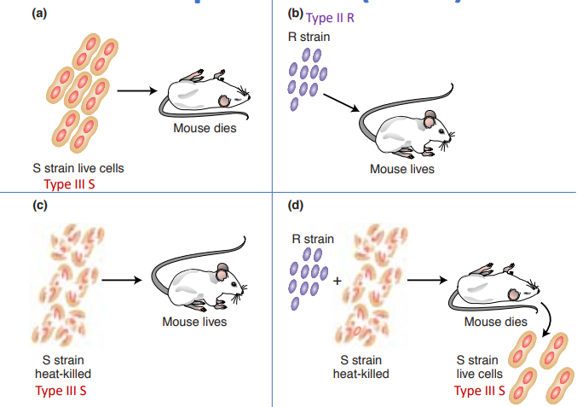Several studies supported the idea that DNA would be the chemical substance that carries genetic information.

* In a 1923 study of Streptococcus pneumoniae bacteria, Frederick Griffith distinguished two bacterial forms: smooth (S) and rough (R). S is the wild type, and it is virulent (pathogenic) with a polysaccharide capsule, while R is a mutation of S and it is avirulent without a polysaccharide capsule. Because the polysaccharide capsule helps protect the bacteria from an animal’s immune response, the S bacteria are virulent and kill most laboratory animals exposed to them (a); by contrast, the R forms fail to cause infection (b).

In 1928, Griffith published the astonishing finding that genetic information from dead bacterial cells could somehow be transmitted to live cells. He was working with two types of the S. pneumoniae bacteria – live R forms and heat-killed S forms. Neither the heat-killed S forms nor the live R forms produced infection when injected into laboratory mice (c); but a mixture of the two killed the animals (d). Furthermore, bacteria recovered from the blood of the dead animals were living S forms. The ability of a substance to change the genetic characteristics of an organism is called transformation. Something from the heat-killed S bacteria must have transformed the living R bacteria into S. This transformation was permanent and most likely genetic, because all future generations of the bacteria grown in culture were the S form.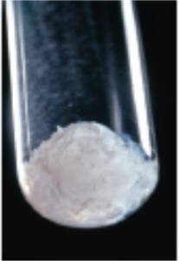

* By 1929, two other laboratories had repeated these results, and in 1931, investigators in Oswald T. Avery’s laboratory found they could achieve transformation without using any animals at all, simply by growing R-form bacteria in medium in the presence of components from dead S forms. Avery tried to identify the heritable substance in the bacterial extract that induces transformation of harmless R bacteria into pathogenic S bacteria. Avery named the substance he was searching for the “transforming element” and spent many years trying to purify it sufficiently to be able to identify it (purified “transforming element” in the picture).

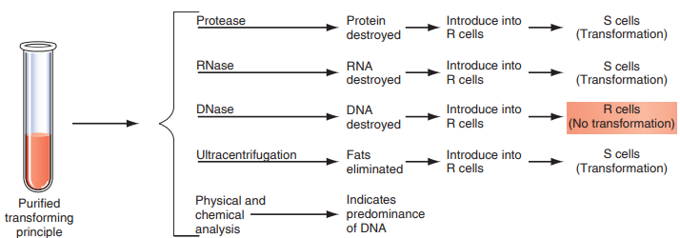The investigators exposed it to various enzymes to see if some molecule other than DNA can cause transformation. Enzymes that degraded RNA, proteins, or polysaccharides had no effect on the transforming principle. This purified extract was still able to cause transformation except when treated with DNase, enzyme that cuts DNA that abolished the ability to induce transformation.

This is the prove that the presence of intact DNA is essential for transformation to occur. The evidence that DNA is the transforming principle was the first demonstration that the hereditary material is composed of DNA.

* The definite prove that DNA is genetic material was done by Hershey and Chase in 1952 using phages (bacteriophages = virus that infect bacteria). These phage particles can reproduce themselves only after infecting a bacterial cell. The question is, what substance contains the information used to produce the new phage particles—DNA or protein? A type of phage known as T2 served as their experimental system (phages components are only DNA and proteins), and they used the newly discovered ability to labeled biological molecule using radioactive isotopes.

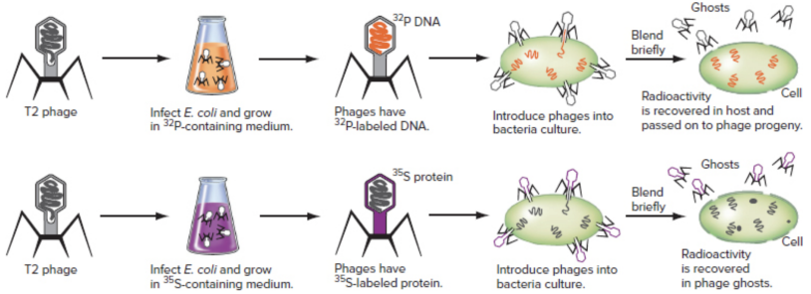They grew two separate sets of T2 in bacteria maintained in two different culture media, one infused with radioactively labeled phosphorus (³²P), the other with radioactively labeled sulfur (³⁵S). Because proteins incorporate sulfur but no phosphorus, and DNA contains phosphorus but no sulfur, phages grown on ³⁵S would have radioactively labeled protein while particles grown on ³²P would have radioactive DNA. The radioactive tags would serve as markers for the location of each material when the phages infected fresh cultures of bacterial cells. After exposing one fresh culture of bacteria to ³²P labeled phage and another culture to ³⁵S labeled phage, Hershey and Chase discovered that the genetic material must be DNA, because radioactivity was found in the phage offspring in the first culture. When radioactivity is contained in the protein component of the phages, did not take part in this process because radioactivity remains outside the cell.

## chemical composition of dna

DNA is a polymer (= linked chain of subunits) of a simple repeating unit. DNA contains four kinds of nucleotides linked in a long chain: nucleotides are made of a sugar (deoxyribose, a 5 carbons atom) connected to a phosphate group on carbon number 5’ and to one of four nitrogenous bases on carbon number 3’.

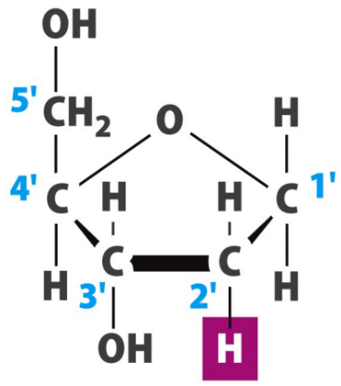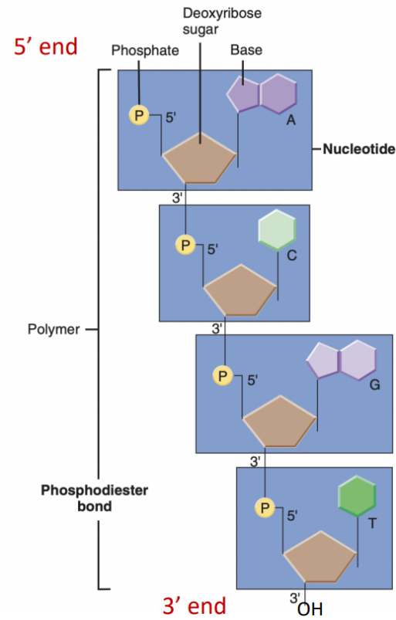A DNA chain composed of many nucleotides has polarity (= an overall direction). Phosphodiester bonds always form a covalent link between the 3’ carbon of one nucleoside and the 5’ carbon of the following nucleoside (nucleoside = sugar + base). The consistent orientation of the nucleotide building blocks gives a chain overall direction, such that the two ends of a single chain are chemically distinct. At the 5’ end, the sugar of the terminal nucleotide has a free 5’ carbon atom. At the other – 3’ – end of the chain, it is the 3’ carbon of the final nucleotide that is free. Along the chain between the two ends, this 5’-to-3’ polarity is conserved from nucleotide to nucleotide. By convention, a DNA chain is described in terms of its bases, written with the 5’-to-3’ direction going from left to right.

The diffraction patterns of oriented DNA fibers studied by Watson and Crick do not, on their own, contain sufficient information to reveal structure, Nevertheless, the photographs do reveal a wealth of structural information. X-ray images produced in 1953 by Rosalind Franklin showed that the molecule is spiral-shaped, or helical. Therefore, based on the results of these three scientists, the DNA was then described as a double helix with two DNA chain that spiral around the central axis.

In this double helix structure, the two chains are going in opposite direction, so they are antiparallel (one chain in going in 5’-to-3’ direction while the other one is going in 3’-to-5’ direction).

The sugar – phosphate backbone is on the outside of the chain, while the base pair are in the middle.

There are four kinds of bases:

* 2 purines (double ring structure)
  + adenine (A)
  + guanine (G)
* 2 pyrimidines (single ring structure)
  + cytosine (C)
  + thymine (T) – in RNA thymine is substituted by uracil (U)

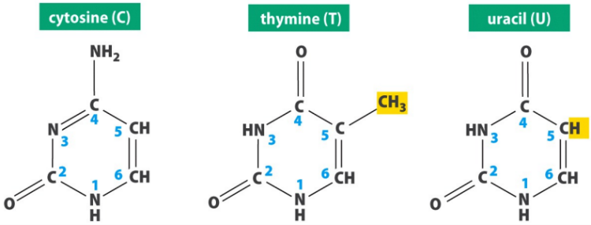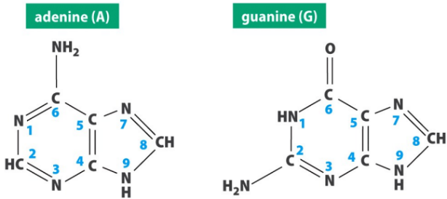

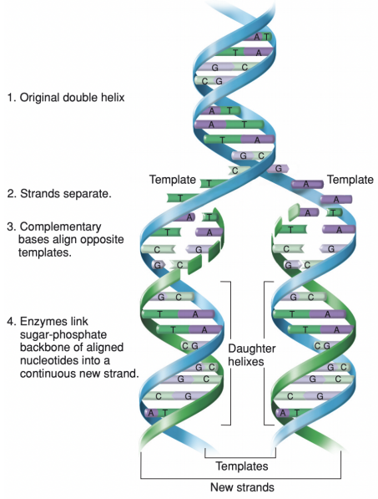If a DNA molecule contains two chains of nucleotides, what forces hold these chains together? Erwin Chargaff provided an important clue with his data on the nucleotide composition of DNA from various species. Despite large variations in the relative amounts of the bases, the ratio of A to T and G to C is not significantly different from 1:1, and the ratio is the same in every organism. To explain Chargaff’s ratios in terms of chemical affinities between A and T and between G and C, Watson made cardboard cutouts of the bases in the chemical forms they assume in a normal cellular environment, and then he tried to match these up in various combinations. He knew that the particular arrangement of atoms on purines and pyrimidines play a crucial role in molecular interactions as they can participate in the formation of hydrogen bonds: weak electrostatic bonds that result in a partial sharing of hydrogen atoms between reacting groups. 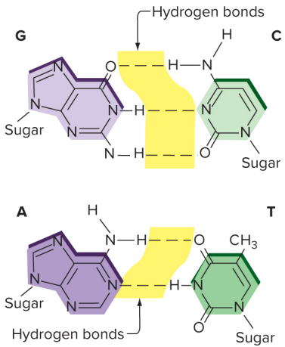Watson saw that A and T could be paired together such that two hydrogen bonds formed between them. If G and C were similarly paired, three hydrogen bonds could connect the nucleotides carrying these two bases. (Watson originally posited two hydrogen bonds between G and C, but there are actually three.) Remarkably, the two pairs – A-T and G-C – had essentially the same shape. This meant that the two pairs could fit in any order between two sugar-phosphate backbones without distorting the structure. It also explained the Chargaff ratios—always equal amounts of A and T and of G and C. Note that both of these base pairs consist of one purine and one pyrimidine.

Remember:

* A=T and G=C
* A+G=50% and T+C=50%

The information content of DNA resides in the sequence of its bases. The four bases in each chain are like letters of an alphabet: each “word” has its own meaning, that is, its own effect on phenotype. Although DNA has only four different letters, the potential for different combinations and thus different sets of information in a long chain of nucleotides is staggering. Some human chromosomes, for example, are composed of chains that are 250 million nucleotides long.

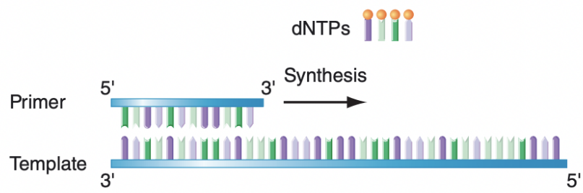DNA replication is s an essential function of the genetic material and it must be executed very precisely if genetic continuity between cells is to be maintained following cell division. When DNA needs to be replicated, the double helix unwinds to expose the bases in each strand of DNA. Each of the two separated strands then serves as template for the synthesis of a new second strand. The enzymes that catalyze the synthesis od DNA are called DNA polymerase. They synthesize DNA in the 5’-to-3’ direction and requires a single-stranded DNA template, a primer, and free deoxyribonucleotides (dNTPs). DNA polymerasethen add nucleotides successively onto the 3ʹ end of the primer as instructed by the complementary nucleotides in the template.

This mechanism of DNA strand separation and complementary base pairing followed by the addition of successive nucleotides yields two “daughter” double helixes that each contain one of the original DNA strands intact (“conserved”) and one completely new strand. For this reason, such a pattern of double helix duplication is called semiconservative replication: a copying in which one strand of each new double helix is conserved from the parent molecule and the other is newly synthesized.

When a linear DNA molecule needs to be replicated, replication start from the so-called origin of replication, but because DNA synthesis occurs only in the 5ʹ→3ʹ direction, one new strand (the leading strand) can be synthesized continuously; the other strand (the lagging strand) needs to be synthesized in pieces, known as Okazaki fragments.

Eukaryotic chromosomes replicate efficiently and relatively quickly because DNA replication is initiated at many origins of replication throughout the genome.

# biochemical genetics

Mendel’s experiments established that an individual gene can control a visible characteristic, but his laws do not explain how genes actually govern the appearance of traits. Investigators working in the first half of the twentieth century carefully studied the biochemical changes caused by mutations in an effort to understand the genotype-phenotype connection.

Biochemistry was being developed at the same time; it studies characteristics and functions of proteins. For several decades the two fields were going in the wrong way because they were not interacting with each other. It was biochemical genetics that posed the bases for molecular biology, that links the two fields.

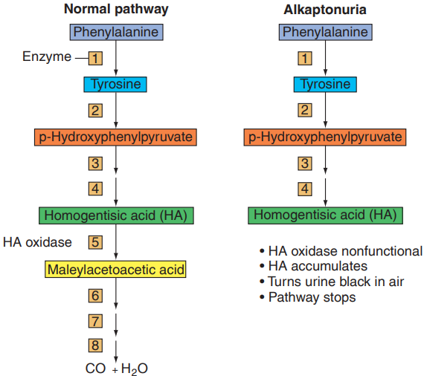In one of the first of these studies, conducted in 1902, the British physician Dr. Archibald Garrod showed that a human genetic disorder known as alkaptonuria is determined by the recessive allele of an autosomal gene. Garrod analyzed family pedigrees and performed biochemical analyses on family members with and without the trait. The urine of people with alkaptonuria turns black on exposure to air. Garrod found that a substance known as homogentisic acid, which blackens upon contact with oxygen, accumulates in the urine of alkaptonuria patients. Alkaptonuriacs excrete all the homogentisic acid they ingest, while people without the condition excrete no homogentisic acid in their urine even after ingesting the substance. From these observations, Garrod concluded that people with alkaptonuria are incapable of metabolizing homogentisic acid to the breakdown products generated by normal individuals.

Because many biochemical reactions within the cells of organisms are catalyzed by enzymes, Garrod hypothesized that lack of the enzyme that breaks down homogentisic acid is the cause of alkaptonuria. In the absence of this enzyme, the acid accumulates and causes the urine to turn black on contact with oxygen. He called this condition an “inborn error of metabolism.” Garrod studied several other inborn errors of metabolism and suggested that all arose from mutations that prevented a particular gene from producing an enzyme required for a specific biochemical reaction. In today’s terminology, the wild-type allele of the gene would allow production of functional enzyme, whereas the mutant allele would not. Because the single wild-type allele in heterozygotes generates sufficient enzyme to prevent accumulation of homogentisic acid and thus the condition of alkaptonuria, the mutant allele is recessive.

In the 1940s, George Beadle and Edward Tatum carried out a series of experiments on the bread mold Neurospora crassa.

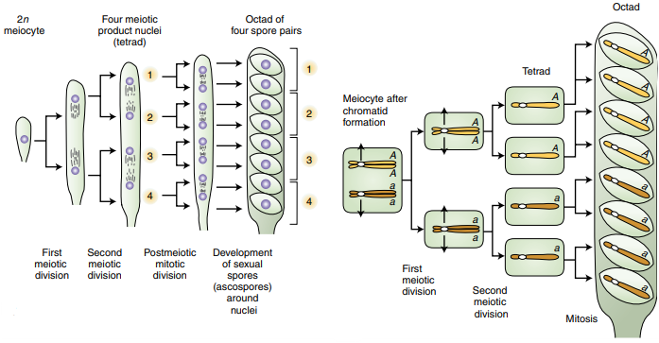Various species of fungi provide a unique opportunity for genetic analysis because they are easily and inexpensively maintained in the lab, and they are haploid so ideal for mutational analysis because mutant alleles are always expressed directly in the phenotype. The spores produced by meiosis of a diploid cell (meiocyte) are held together in a sac called ascus. These haploid cells, or ascospores, can germinate and survive as viable haploid individuals that grow and perpetuate themselves by mitosis. One, the baker’s yeast (Saccharomyces cerevisiae), generates four ascospores with each meiosis; while the Neurospora crassa still generates four ascospores with each meiosis, but at the completion of meiosis, each of the four haploid ascospores immediately divides once by mitosis to yield four pairs, for a total of eight haploid cells. The two cells in each pair of Neurospora ascospores have the same genotype, because they arose from mitosis.

The experiment took by Beadle and Tatum demonstrated a direct relation between genes and the enzymes that catalyze specific biochemical reactions.

They first isolated several mutations that interrupt synthesis of the amino acid arginine, a compound needed for Neurospora growth. They hypothesized that different mutations blocked different steps in a particular biochemical pathway: the orderly series of reactions that allows Neurospora to obtain simple molecules from the environment and convert them step-by-step into successively more complicated molecules culminating in arginine.

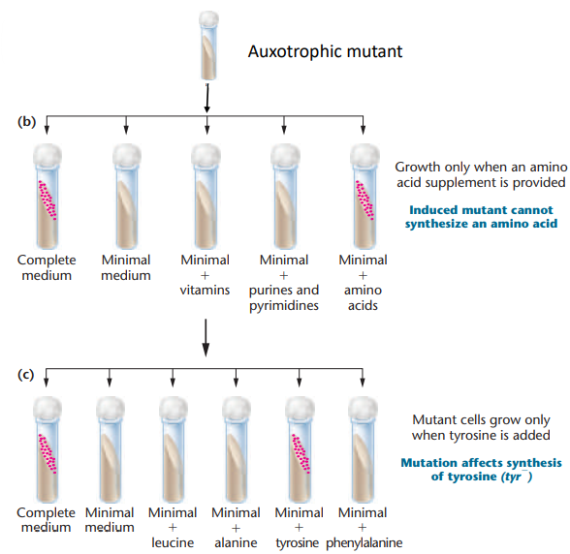They first obtained a set of mutagen-induced mutations that prevented Neurospora from synthesizing arginine. Cells with any one of these mutations were unable to make arginine and could therefore grow on a minimal medium containing salt and sugar only if it had been supplemented with arginine. A nutritional mutant microorganism that requires supplementation with substances not needed by wild-type strains is known as an **auxotroph**. The cells just mentioned were arginine auxotrophs (in contrast, a cell that does not require addition of a substance is a prototroph for that factor; in a more general meaning, prototroph refers to a wild-type cell that can grow on minimal medium alone.) Recombination analyses located the auxotrophic arginine-blocking in four distinct regions of the genome, and complementation tests showed that each of the four regions is correlated with a different complementation group. Based on these results, Beadle and Tatum concluded that at least four genes support the biochemical pathway for arginine synthesis. They named the four genes arg-e, arg-f, arg-g, and arg-h. They next asked whether any of the mutant Neurospora strains could grow in minimal medium supplemented with any of three known intermediates (ornithine, citrulline, and arginosuccinate) in the biochemical pathway leading to arginine, instead of with arginine itself. This test would identify Neurospora mutants able to convert the intermediate compound into arginine. Beadle and Tatum compiled a table describing which arginine auxotrophic mutants were able to grow on minimal medium supplemented with each of the intermediates.

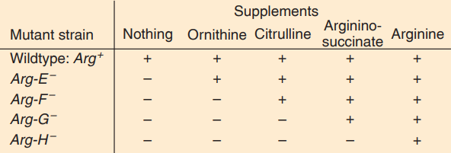In the linear progression of biochemical reactions by which a cell constructs arginine from the constituents of minimal medium, each intermediate is both the product of one step and the substrate for the next. Each reaction in the precisely ordered sequence is catalyzed by a specific enzyme, and the presence of each enzyme depends on one of the four arg- genes.

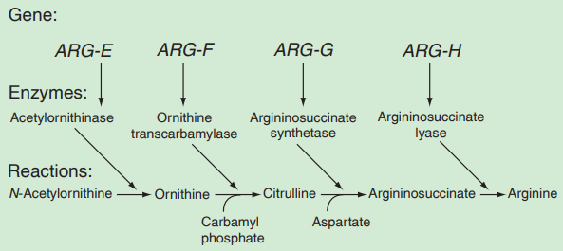By correlating genetic analyses with biochemical studies of the mutant strains, they demonstrated that each mutation resulted in the loss of one enzyme activity. A mutation in one gene blocks the pathway at a particular step, because the cell lacks the corresponding enzyme and thus cannot make arginine on its own. Supplementing the medium with any intermediate that occurs beyond the blocked reaction restores growth because the organism has all the enzymes required to convert the intermediate to arginine. Supplementation with an intermediate that occurs before the missing enzyme does not work because the cell is unable to convert the intermediate into arginine. Each mutation abolishes the cell’s ability to make an enzyme capable of catalyzing a certain reaction.

Although the analysis of the arginine pathway studied by Beadle and Tatum was straightforward, studies of biochemical pathways are not always so easy to interpret. Some biochemical pathways are not linear progressions of stepwise reactions.

# from gene to protein

## the central dogma

“Within each cell, genetic information flows from DNA to RNA to protein”.

The central dogma of molecular biology states that information encoded in DNA is transferred to RNA, which then directs the synthesis of proteins based on these instructions. First in the process of transcription, DNA is used as a template to synthesize messenger RNA, mRNA, which represents a copy of the coding strand, except the thymidines are replaced uracils. Next in the process of translation in eukaryotes, mRNA travels to a ribosome. Here, codons, groups of three nucleotides in the mRNA, bind to complementary sequences on transfer RNA, tRNA molecules, each of which is attached to a particular amino acid depending on the specific codon. For example, the codon and CCA binds to a tRNA attached to proline, while a GC bind to a tRNA attached to serine. in this way the genetic code specified the order in which the amino acids are arranged in the resulting polypeptide. Polypeptides are often then further processed to become functional proteins.

## transcription

Transcription is the process by which the polymerization of ribonucleotides guided by complementary base pairing produces an RNA transcript of a gene. The template for the RNA transcript is one strand of that portion of the DNA double helix that composes the gene.

Basic components of transcription:

* the enzyme RNA polymerase catalyzes transcription
* DNA sequences near the beginning of genes, called promoters, signal RNA polymerase where to begin transcription
* RNA polymerase adds nucleotides to the growing RNA polymer in the 5’-to-3’ direction. The chemical mechanism of this nucleotide-adding reaction is similar to the formation of phosphodiester bonds between nucleotides during DNA replication with one exception: transcription uses ribonucleotide triphosphates instead of deoxyribonucleotide triphosphates. Therefore, the nucleotide sequence of the primary RNA transcript is complementary to that of the template strand and so it is identical to that of the sense strand, except that U replaces T
* Sequences in the RNA products, known as terminators, tell RNA polymerase where to stop transcription.

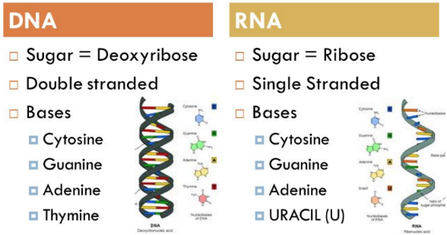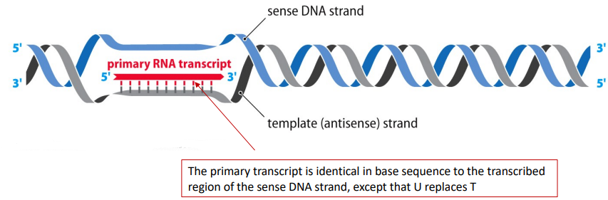The result of transcription is a single strand RNA known as a primary transcript. The primary RNA transcript needs to be modified in order to obtain a processed final messenger RNA molecule. Transcription produces a pre-mRNA that is processed by the addition of a 5ʹ 7-mG cap and a 3ʹ poly-A tail. Unexpectedly, both the cap and the poly-A tail are critical for the efficient translation of the mRNA into protein, even though neither helps specify an amino acid.

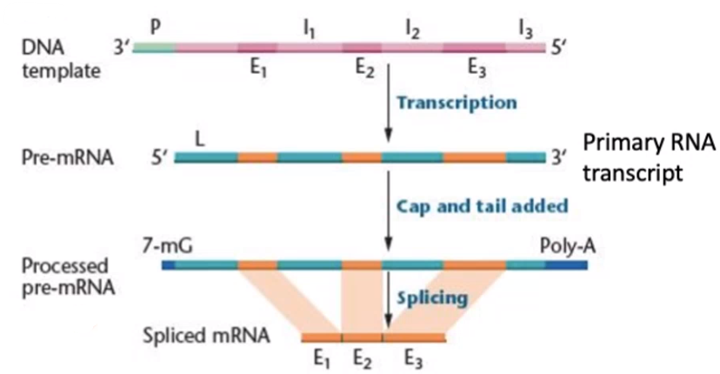Geneticists’ expectation was that the DNA nucleotide sequence of a gene’s RNA-like strand would be identical to the RNA nucleotide sequence of the messenger RNA (except for U replacing T in the RNA). Surprisingly, they found that the DNA nucleotide sequences of many eukaryotic genes are much longer than their corresponding mRNAs, suggesting that RNA transcripts, in addition to receiving a cap and a poly-A tail, undergo extensive internal processing. Sequences found in both a gene’s DNA and the mature messenger RNA are called **exons** (= expressed regions). The sequences found in the DNA of the gene but not in the mature mRNA are known as introns (=intervening regions). Introns interrupt, or separate, the exon sequences that end up in the mature mRNA.

Whenever we transcribe a piece of DNA, the primary transcript will contain both coding exons and non-coding introns, but they must be removed.

The process that eliminates the non-coding part, the introns, from the primary RNA transcript, is called splicing. It involves the removal of introns by an excision process and the rejoining of the exons.

## translation

Translation is the process that decodes messenger RNA in order to make polypeptides.

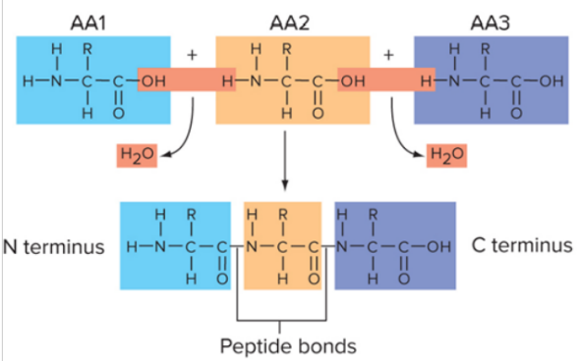A protein consists of one or more polypeptides, that are polymers made of amino acids.

The amino acid common structure consists of a central carbon atom to which is bonded:

* 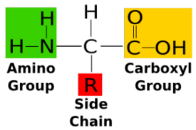an amino group (NH₂)
* a carboxyl group (COOH)
* a hydrogen atom
* the R group, which is specific for each amino acid, giving

distinctive properties

There are 20 different amino acids, that are joined together by peptide bond, that is a covalent bond formed between the carboxyl group of one amino acid and the amino group of an adjacent amino acid.

At the molecular level, translation decodes the information in mRNA leading to the synthesis of polypeptide chains. mRNA is translated into a specific sequence of amino acids based on the genetic code.

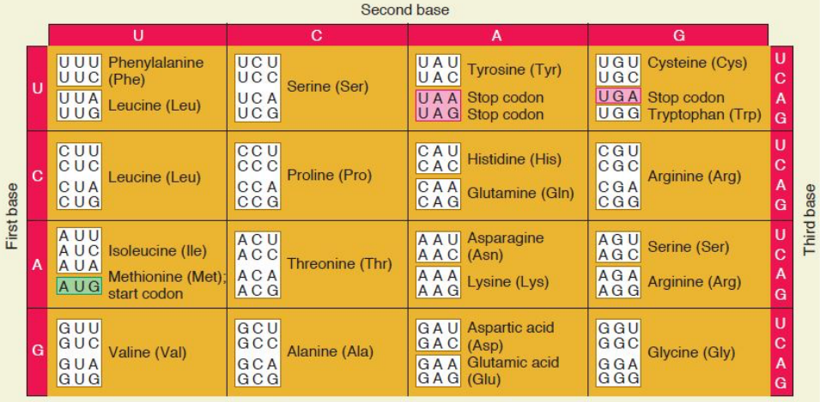The “language” of nucleic acids is written in four nucleotides – A, G, C and T in the DNA dialect; A, G, C and U in the RNA dialect – while the language of proteins is written in amino acids.

How can four nucleotides encode 20 amino acids? The mRNA sequence is read in groups of 3 nucleotides known as codons. So, triplet codons of nucleotides represent individual amino acids. Actually, a 3-base codon system can specify 4³=64 different codons. Because the number of possible codons exceeds 20 (which is the number of different types of amino acids) the genetic code is termed degenerate: more than one codon can specify the same amino acid.

There are three different triplets – UAA, UAG, and UGA – that does not correspond to any of the amino acids. When these codons appear in frame, translation stops. They are called stop codons or nonsense codons and are used to end the process of translation.

On the other end, the codon AUG, that specifies methionine, is used as a start codon; it is usually the first codon that begins a polypeptide sequence.

As we just said, the start codon AUG defines the reading frame of an mRNA. Translation involves the interactions of mRNA, tRNA, ribosomes, and a variety of translation factors essential to the initiation, elongation, and termination of the polypeptide chain.

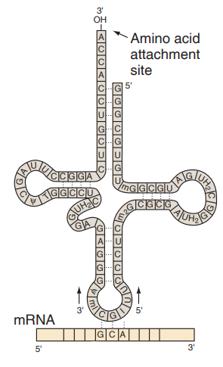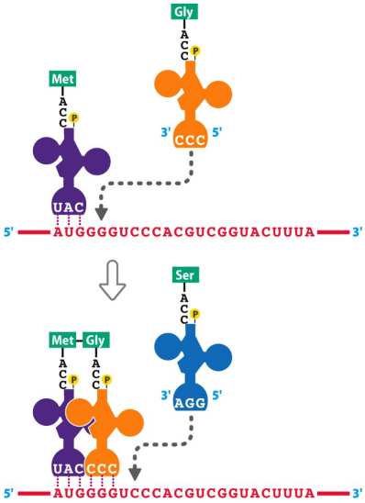Polypeptide synthesis takes place on ribosomes, where the genetic message encoded in mRNA is translated. Amino acids are brought to the ribosome bound to tRNA molecules. Transfer RNAs are responsible for transporting the correct amino acids in sequence. They serve as adaptor RNAs because their job is to base pair with mRNAs. The base pairing is confined to a three-nucleotide sequence in the tRNA called an anticodon, which is complementary in sequence to a codon on the mRNA.

The anticodon in the tRNA binds to the complementary sequence in the mRNA. At its other end, the tRNA carries the amino acid that corresponds to the codon in the mRNA via the genetic code. Through base pairing between codon and anticodon, individual amino acids can be sequentially ordered according to the sequence of codons in an mRNA, and sequentially linked together to form a polypeptide chain. At each step of translation, the polypeptide grows by the addition to its C terminus (carboxyl terminal) of the next amino acid in the chain.

The mRNA is translated in the 5’-to-3’ direction, and the polypeptide is made in the N-terminal-to-C-terminal direction (amino terminal to carboxyl terminal, that corresponds to 5’-to-3’ in the mRNA).

DNA sequence 🡪 transcription 🡪 mRNA sequence 🡪 translation (tRNA intermediate) 🡪 amino acids sequence of a polypeptide

## open reading frame

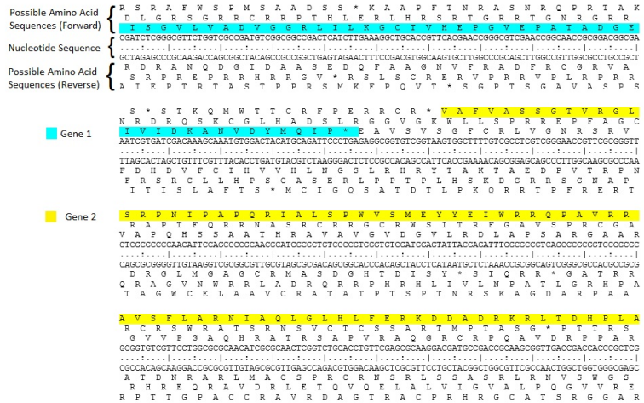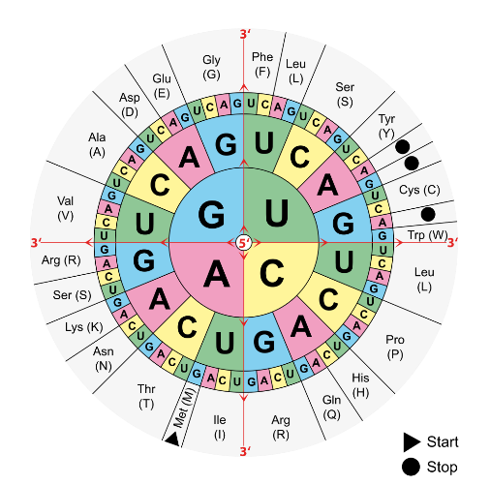An open reading frame is a portion of a DNA molecule that, when translated into amino acids, contains no stop codons. The genetic code reads DNA sequences in groups of three base pairs, which means that a double-stranded DNA molecule can read in any of six possible reading frames – three in the forward direction and three in the reverse. A long open reading frame is likely part of a gene.

A double-stranded DNA molecule can be read in any of six possible reading frames (three in the forward direction and three in the reverse).

# genetic variation - molecular mechanisms of mutations

Mutation = a heritable (stable) change in the base-pair sequence of DNA

* sources of genetic variation and of phenotypic variability
* provide basis for adaptation to environmental changes and evolution
* genetic changes can also lead to disease
* provide the primary tools for genetic analysis

There are two types of mutations:

* 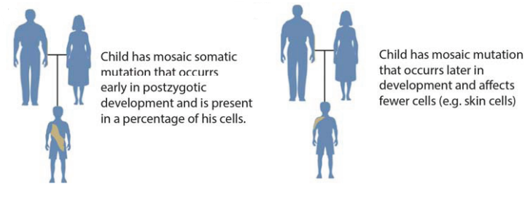somatic mutations, that occur in somatic cells, and are not passed on to progeny by reproduction. Somatic mutation may occur relatively early in development or at any later time throughout the lifespan, generally affecting fewer cells. If the mutation occurs at an early stage of development, it will give rise to an individual with two or more genetically different types of cells (mosaic; mosaics have two or more genetically different cell lines derived from a single zygote).
* germline mutations, that occur in germ cells (egg or sperm) and are passed to progeny by reproduction. There are two type of germline mutations:
  + 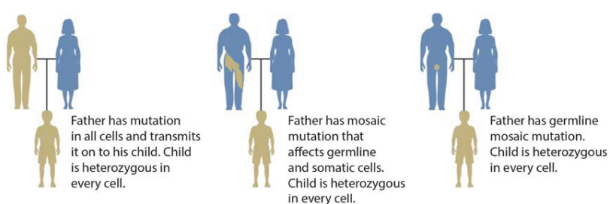inherited mutations, that are always transmitted through the germline, although a parent may also have a mosaic mutation
  + 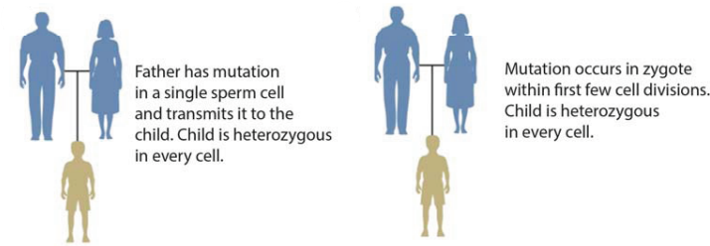de novo mutations, that are defined as genotypes observed in a child but not in either parent. They may originate in a parental germ cell or postzygotically

Mutation is an event or a process that produces a heritable change in DNA sequence, but sometimes the term is used to describe the outcome of that process, the DNA variant (the change in DNA sequence), especially when it is associated to altered phenotype.

Depending on how DNA variants are frequent in the population we can distinguish:

* Population frequency > 1% 🡪 DNA polymorphisms (sequence differences)
* Population frequency < 1% 🡪 rare variants

To prevent confusion the HGVS (Human Genome Variation Society) recommends using neutral terms like “variant”, “change” and “allelic variant”.

## Genetic variation, from single base to chromosome

Genetic mutation:

* Variation in chromosome number
* Structural Variations (VS):
  + Chromosome rearrangement (> ~ 5 Mb, cytogenetically visible)
  + Submicroscopic (from 1 kb to ~ 5 Mb)
* Point mutation or short genetic variation, that affect one or just a few base pairs in the DNA and thus alter only one gene at a time:
  + Single Nucleotide Variants (SNV)

SNVs are the most common type of DNA variation.

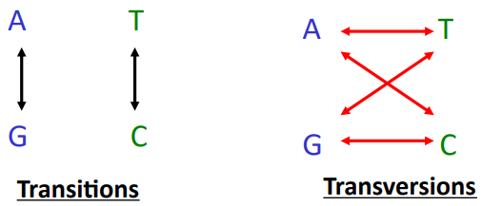It occurs when a base is replaced by one of the other bases; after DNA replication, a new base pair will appear in the daughter double helix. These substitutions can be subdivided into transitions, in which one purine (A or G) replaces the other purine, or one pyrimidine (C or T) replaces the other; and transversions, in which a purine changes with a pyrimidine, or vice versa.

Common SNVs are called SNPs (= Single Nucleotide Polymorphisms)

* + Insertions – Deletions (indel)
  + Microsatellite (short tandem repeat) variants

## S. Luria and M. Delbrück (1943) – Fluctuation test

In one study, investigators spread wild-type bacteria on the surface of agar containing sufficient nutrients for growth as well as a large amount of a bacteria-killing substance, such as an antibiotic or a bacteriophage. Although most of the bacterial cells died, a few showed resistance to the bactericidal substance and continued to grow and divide. The descendants of a single resistant bacterium, produced by many rounds of binary fission, formed a mound of genetically identical cells called a colony.

Had the cells in the colonies somehow altered their internal biochemistry to produce a life-saving response to the antibiotic or bacteriophage? Or did they carry heritable mutations conferring resistance to the bactericide? And if they did carry mutations, did those mutations arise by chance from random spontaneous events that take place continuously, even in the absence of a bactericidal substance, or did they only arise in response to environmental signals?

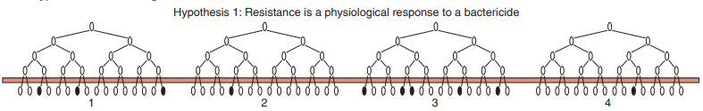In 1943, Salvador Luria and Max Delbrück devised an experiment to examine the origin of bacterial resistance. According to their reasoning, if bacteriophage-resistant colonies arise in direct response to infection by bacteriophages, separate suspensions of bacteria containing equal numbers of cells will generate similar, small numbers of resistant colonies when spread in separate petri plates on nutrient agar suffused with phages.

By contrast, if resistance arises from mutations that occur spontaneously even when the phages are not present, then different liquid cultures, when spread on separate petri plates, will generate very different numbers of resistant colonies. The reason is that the mutation conferring resistance can, in theory, arise at any time during the growth of the culture. If it happens early, the cell in which it occurs will produce many mutant progeny prior to petri plating; if it happens later, there will be far fewer mutant progeny when the time for plating arrives.

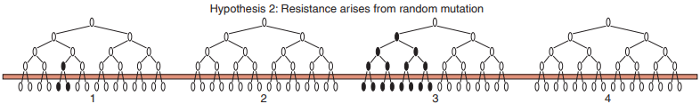After plating, these numerical differences will show up as fluctuations in the numbers of resistant colonies growing in the different petri plates.

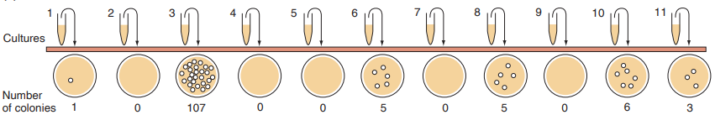The results of this fluctuation test were clear: most plates supported zero to a few resistant colonies, but a few harbored hundreds of resistant colonies. From this observation of a substantial fluctuation in the number of resistant colonies in different petri plates, Luria and Delbrück concluded that bacterial resistance arises from mutations that exist before exposure to bacteriophage. After exposure, however, the bactericide in the petri plate becomes a selective agent that kills off nonresistant cells, allowing only the preexisting resistant ones to survive.

In conclusion, many mutations in a genome occur spontaneously from endogenous factors, and they occur randomly (not directed by the environment).

## Causes of spontaneous mutations

The causes of spontaneous mutations are:

* DNA replication errors
  + 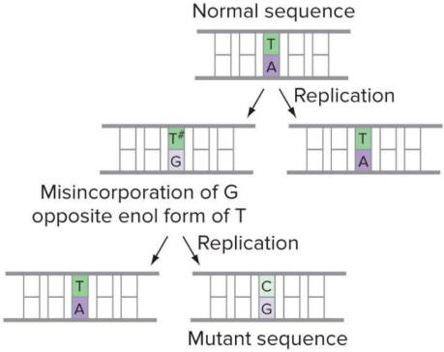Misincorporation of nucleotides

One reason why DNA polymerase may make mistakes is the tautomerization of bases. Each of the four bases has two tautomers, similar chemical forms that interconvert continually. The equilibrium between tautomers is such that each base is almost always in the form in which A pairs with T and G pairs with C. However, if by chance a base in the template strand is in its rare tautomeric form when DNA polymerase arrives, the wrong base will be incorporated into the newly synthesized chain because the rare tautomers pair differently than do the normal forms (T-G and C-A). If the misincorporated nucleotide is not corrected by DNA repair before the next round of replication, a point mutation results.

* + DNA Pol replication slippage

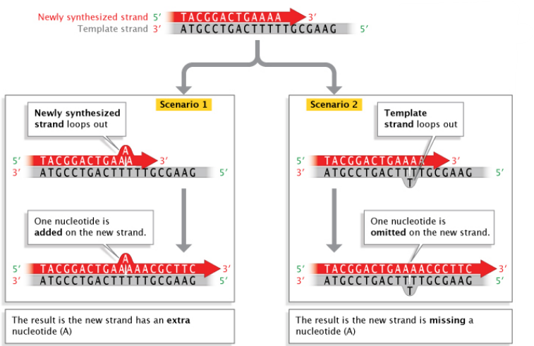

DNA polymerase often pauses as it replicates through repeat regions, which allows one DNA strand (either the newly synthesized strand or the template strand) to slip relative to the other one. Because the sequence contains repeats, the slipped strand and the other strand can pair out of register forming a loop. After another round of DNA replication, this slipped mispairing can result in expansion or contraction of trinucleotide repeat number in both DNA strands. Sequences with short tandem repeats are prone to this kind of error.

* Endogenous chemical damage to DNA
  + Hydrolytic damage – depurination and deamination

Depurination: DNA alteration in which the hydrolysis of a purine base, either A or G, from the deoxyribose-phosphate backbone occurs. An apurinic site will be formed and, because it cannot specify a complementary base, the DNA replication process sometimes introduces a random base opposite the apurinic site, causing a mutation in the newly synthesized complementary strand three-quarters of the time.

Deamination: the removal of an amino (-NH₂) group from normal DNA.

Deamination can change cytosine to uracil, the nitrogenous base found in RNA but not in DNA. Because U pairs with A rather than G, deamination followed by replication may alter a C–G base pair to a T–A pair in future generations of DNA molecules

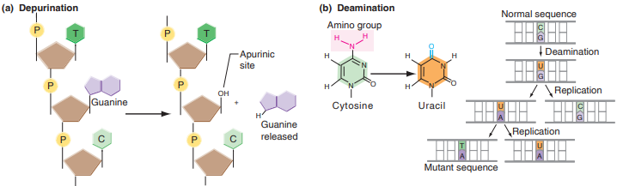

* + 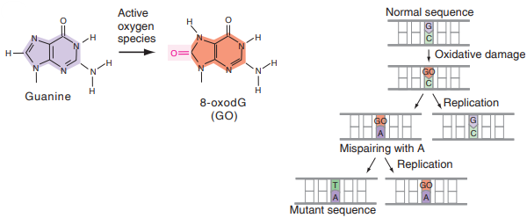Oxidative damage

Irradiation causes the formation of free radicals (such as oxygen molecules with an unpaired electron) that can alter individual bases. Here, the pairing of the altered base GO with A creates a transversion that changes a G–C base pair to T–A.

But it can also produce many different types of chemical modifications in DNA such a the loss of bases and a DNA strand break.

* + UV – X rays radiations

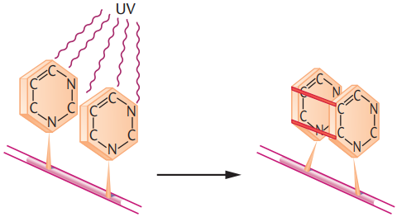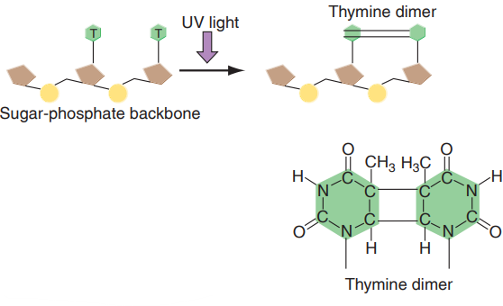Ultraviolet (UV) light causes adjacent thymine to form abnormal covalent bonds (thymine dimers). Dimers distort the DNA conformation and inhibit normal replication.

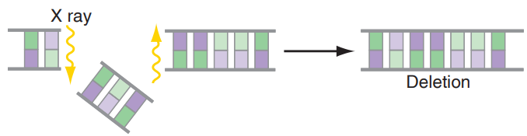X rays penetrate more deeply into tissues, and it can cause ionization of the molecules, and generate free radicals. Free radicals can directly or indirectly damage DNA (purines and pyrimidines modifications; phosphodiester bonds breaks; double strand breaks, chromosomal aberrations, such as deletions and translocations)

Other errors can happen in chromosome segregations during cell division (= aneuploidy), during recombination or the reparation of chromosome breaks (structural variations).

## dna repair mechanism

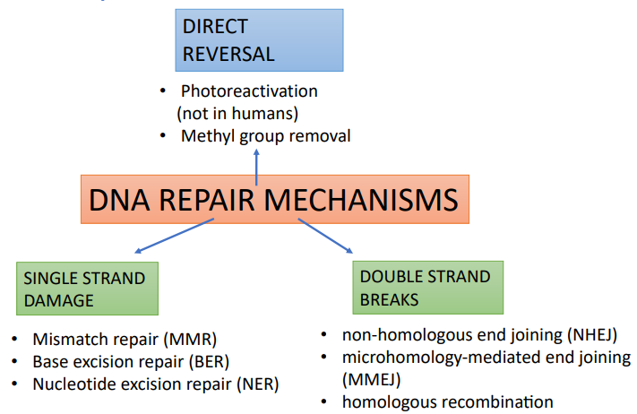DNA repair systems are essential to the maintenance of the genetic integrity of organisms (mutation rates are kept low by DNA repair mechanisms). The balance between mutation and repair results in the observed mutation rates

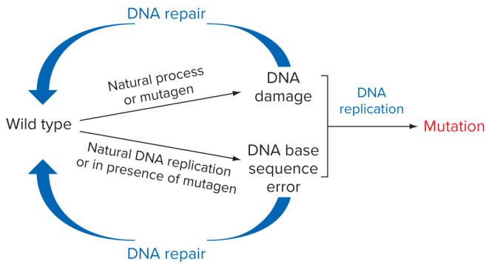

There are different mechanisms and each of these is responsible to repair a specific mutation.

When there is only one strand damaged, use info in the opposite strand to repair the damage.

Double stranded damages are more difficult to repair, because there is no information that is present in the opposite strands, both strands are broken. There are two possibilities to repair a double stranded break: one is to use a system that is very similar to homologous recombination that takes place during meiosis. This system, homologous recombination repair, is possible only after the S phase, so when chromatid have already replicated. After the replication, each chromosome is composed of 2 sister chromatids, so the homologous recombination repair system can use the info that is present in the sister chromatids to recover this break.

If the cell is in G1, so the cell has not replicated yet, and there is only one chromatid, there is no way to repair a double stranded like that. So, in this situation, there is another mechanism, nonhomologous end joining, which allows to rejoin some broken strands, but this mechanism often makes mistakes.

# genetic variation – effect on gene expression and function

## consequences of point mutations

Short sequence variants can be defined according to their effects on amino acid sequences in proteins:

* 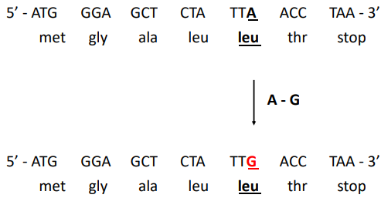synonymous (silent) mutations

Silent mutations are mutations without effect on the phenotype. Usually denotes point mutations that change one of the three bases in a codon but that do not change the identity of the specified amino acid because of the degeneracy of the genetic code.

The majority of silent mutations change the third nucleotide of a codon, the position at which most codons for the same amino acid differ. Third base transitions are almost always silent; third base transversions may results in missense changes.

For example, a change from GCA to GCC in a codon would still yield alanine in the protein product.

Because silent mutations do not alter the amino acid composition of the encoded polypeptide, such mutations have no effect on any of the phenotypes influenced by the gene.

* Missense mutations

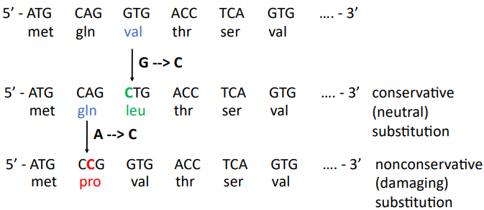Mutations that change a codon into a mutant codon that specifies a different amino acid are called missense mutations. If the substituted amino acid has chemical properties similar to the one it replaces, then it may have little or no effect on protein function. Such substitutions are conservative (neutral). For example, a mutation that alters a GAC codon for aspartic acid to a GAG codon for glutamic acid is a conservative substitution because both amino acids have acidic R groups.

By contrast, nonconservative (damaging) missense mutations that cause substitution of an amino acid with very different properties are likely to have more noticeable consequences. A change of the same GAC codon for aspartic acid to GCC, a codon for alanine (an amino acid with an uncharged, nonpolar R group), is an example of a nonconservative substitution. The effect on phenotype of any missense mutation is difficult to predict because it depends on how a particular amino acid substitution changes a protein’s structure and function.

* Nonsense mutations

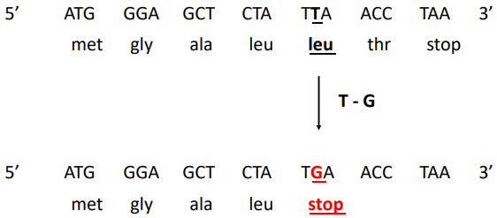Mutations known as nonsense mutations change an amino acid–specifying codon to a premature termination (stop) codon. Nonsense mutations, therefore, result in the production of shortened truncated proteins, smaller than those encoded by wild-type alleles of the same gene. These proteins lack all amino acids between the amino acid encoded by the mutant codon and the C terminus of the normal polypeptide.

The mutant polypeptide will be unable to function if it requires the missing amino acids for its activity (usually produces loss of function).

Nonsense-mediated dacay: surveillance pathway, which eliminates mRNA that contain premature STOP codons, to avoid production of aberrant truncated protein.

* 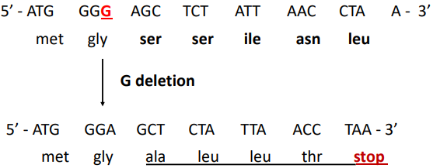Frameshift mutations

Frameshift mutations result from the insertion or deletion (indel) of nucleotides within the coding sequence (the series of codons specifying the amino acids of the gene product). As discussed earlier, if the number of extra or missing nucleotides is not divisible by 3, the insertion or deletion will skew the reading frame downstream of the mutation. As a result, frameshift mutations cause unrelated amino acids to appear in place of amino acids critical to protein function, destroying or diminishing polypeptide function.

Also, mutations in non-coding sequence can alter the function of a gene, or may alter the process of gene expression, or mRNA stability. For example, we can have variance mutations in the regulatory elements (enhancers, silencers) or in regions important for the splicing

Splicing is regulated by the presence of some splicing consensus sequence, that are recognize by the spliceosome, the complex that is responsible for the removal of the introns. If you alter the sequence immediately after the first exon and the area right before the second exon, there can be errors in the splicing). In most cases they are damage because they produce a nonfunctional protein.

## functional consequences of mutations

The terms dominant and recessive have a phenotypic basis. The dominance of one allele over another is influenced by the effect of that allele on the protein product; the overall phenotype is the consequence of the activities of the protein products of the alleles of the gene.

We can distinguish between two consequences:

* loss of function

Any mutation inside or outside a coding region that reduces or abolishes protein activity is a loss-of-function mutation.

example: nonsense, frameshift, damaging missense, alteration of splicing, disruption of promoter/regulatory elements…

* + Recessive

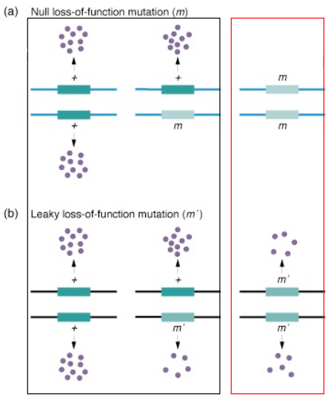Loss-of-function alleles that completely block the function of a protein are called **null mutations**, or **amorphic mutations**. Such mutations either prevent synthesis of the polypeptide or promote synthesis of a protein incapable of carrying out any function. Has a recessive effect on phenotype.

For example, in an A⁺ / a heterozygote, in which allele a is recessive to wild-type allele A⁺, the A⁺ allele would generate functional protein, while the null a allele would not. If the amount of protein produced by the single A⁺ allele is above the threshold amount sufficient to fulfill the normal biochemical requirements of the cell, the gene is said to be haplo-sufficient, and the phenotype of the A⁺ / a heterozygote will be wild type. For the large number of genes that function in this way, A⁺/ A⁺ cells actually make more than twice as much of the protein needed for the normal phenotype. The mutant phenotype is seen only when there is a total or partial loss of the gene function.

A **hypomorphic** mutation is a loss-of-function mutation that produces either much less of a protein or a mutant protein that functions less effectively than the wild type. In a B⁺ / b heterozygote, where b is a hypomorphic allele recessive to wild-type allele B⁺, the amount of protein activity will be somewhat greater than half the amount in a B⁺ / B⁺ cell. Usually, this is enough activity to fulfill the normal biochemical requirements of the cell. Most hypomorphic mutations are detectable only in homozygotes, and only if the reduction in protein amount or function is sufficient to cause an abnormal phenotype.

* + 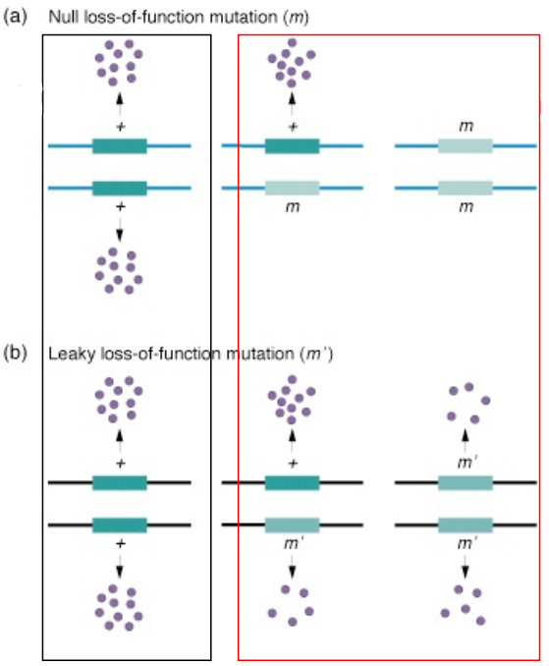Dominant

It could also be possible to have loss-of-function mutations that are dominant on the phenotype, because of the haploinsufficiency, that is a characteristic of dosage-sensitive gene, gene that must be expressed at the right amount to assure a normal phenotype. The term haploinsufficiency describes relatively rare situations in which one wild-type allele does not provide enough of a gene product to avoid a mutant phenotype (the loss of function mutation in the heterozygous and homozygous state reduces the level of gene product below the level needed for wild-type phenotype).

One example of a human haploinsufficient gene is GLI3, which encodes a transcription factor important for the specification of digits. Heterozygosity for loss-of-function mutations in GLI3 causes one form of polydactyly (presence of extra fingers and toes). GLI3 mutant homozygotes are inviable because the GLI3 gene is pleiotropic (controls more than the number of digits).

* gain of function

Rare mutations that enhance a protein’s function or even confer a new activity on a protein produce gain-of-function allele. Because a single such allele by itself usually produces a protein that can alter phenotype even in the presence of the normal protein, these unusual gain-of-function mutant allele are almost dominant to wild-type alleles. Many dominant gain-of-function mutant alleles are lethal when homozygous because they are pleiotropic.

Examples: missense change that alters the function of a protein, gene amplification, alteration of regulatory sequences…

* + hypermorphic mutation

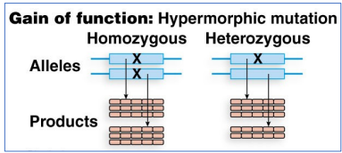excessive or ectopic expression of the gene product.

A hypermorphic mutation is a gain-of-function mutation that generates either more protein than the wild-type allele or the same amount of a more efficient protein.

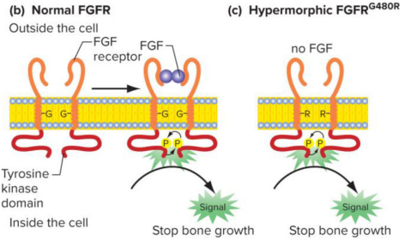For example, a hypermorphic mutation in the human FGFR3 gene results in achondroplasia. The FGFR3 gene encodes a signaling protein that inhibits bone growth. FGFR3 protein is a normally activated only when a small protein called FGF (fibroblast growth factor) binds to it. Most people with achondroplasia carry a mutant allele called FGFR3ᴳ⁴⁸⁰ᴿ, which encodes an FGFR3 protein with arginine instead of the normal glycine. This single amino acid change causes the mutant protein to become activated even in the absence of FGF. The mutant protein thus constitutively active receptors that is activated all the time. The hypermorphic allele (FGFR3ᴳ⁴⁸⁰ᴿ) is dominant to the wild-type allele because the mutant protein inhibits bone growth even if the normal protein is present.

b) FGFR3 encodes a receptor that is normally activated only when it is bound to the hormone FGF.

c) mutant FGFR3ᴳ⁴⁸⁰ᴿ protein is always activated whether FGF is present or not, leading to improper bone development.

* + 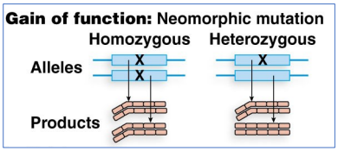neomorphic mutation

the mutant allele has a novel/altered function.

A rare class of dominant gain-of-function alleles arises from neomorphic mutations that generate a novel phenotype. Some neomorphic mutations produce proteins with a new function, while others cause genes to produce the normal protein but at an inappropriate time or place.

* + Dominant-negative mutations

The mutant gene product acts antagonistically to the wild-type allele.

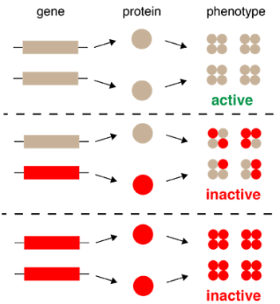Some dominant mutant alleles of genes encode proteins that not only fail to provide the activity of the wild-type protein but also prevent the normal protein from functioning. Such alleles are called dominant-negative, or antimorphic, alleles.

In the heterozygote state, the mutant allele interferes with the function of the wild-type allele by specifying polypeptides that inhibit, antagonize, or limit the activity of the wild-type polypeptide

# genetic variation - Variation in chromosome number and structural variation

This kind of generic variation are distinguishable in 3 different categories also because of technological region, for the different approaches that are normally used to observe this kind of variance:

* Short sequences variance: we use standard molecular genetic techniques such as DNA sequencies, PCR cloning…
* Larger variance (> 3000 bases): we use microarrays
* Chromosomal rearrangement: we use the karyotype – cytogenetic analysis

## karyotype analysis

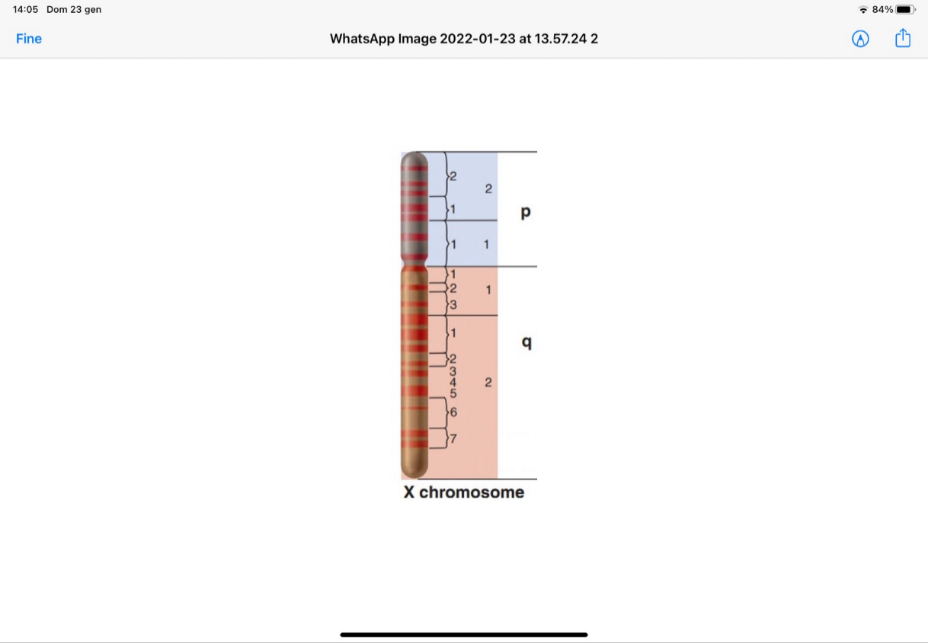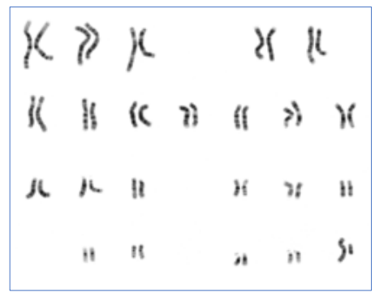Karyotype describes the chromosome count of an organism and what these chromosomes look like under a light microscope.

Different banding techniques are used to visualize the chromosomes: various standing techniques reveal a characteristic banding pattern, size, and shape for each metaphase chromosome, establishing a karyotype. In G-banding, for instance, chromosomes are first heated and then exposed to Giemsa. This DNA marks dye preferentially darkens regions that tend to be heterochromatic (A-T rich and late-replicating); the light regions tend to be euchromatic (G-C rich and early-replicating). This method will normally produce 300–400 bands in a normal, human genome.

The reproducibility of this pattern means that geneticists can designate the chromosomal location of a gene by describing its position in a relation to the bands on the p (short) or q (long) arm of a particular chromosome. For this purpose, the p and q arms are subdivided into regions and within each region the dark and light bands are numbered consecutively.

## microarray

Microarray is solid support on which DNA fragments of known sequence (probes) are deposited in a precise pattern.

Array can be used in order to find difference in the level of copied number in the genome in comparison to another genome.

Structural variants: variations that alter the number of copies of a specific sequence between one person and another person. When a DNA segment (large) is present in a different number of copies

deletions and duplication of a specific segment of DNA

in order to identify if a gene contains these you can rase array technologies, by comparing the genome from a test individual to the genome of a control individual, just comparing the number of copies between two different genome.

You can scan the genome by comparing the amount of hybridization in the test vs the control you see when there is a greater amount of hybrid in one color vs the other color to identify all the regions that are duplicated or deleted in the test sample compared to the control sample.

## variation in chromosome number

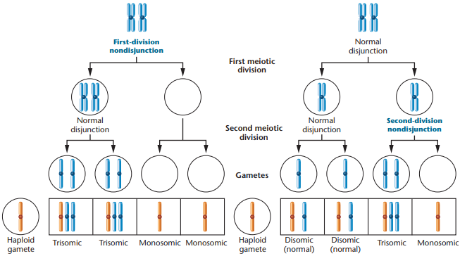Individuals whit an abnormal number of chromosomes are called:

* Aneuploidy: gain or loss of one chromosome
  + Monosomy: loss of 1 chromosome
  + Trisomy: gain of 1 chromosome
* Polyploidy: more than two haploid sets are present

(Euploidy is the normal situation in which a complete set of chromosome is present)

Consequences:

Monosomy for any of the autosomes is not usually tolerated in humans or other animals, while trisomy for an autosome is slightly more tolerated in humans or other animals (i.e. trisomy 21), but otherwise lethal. In plants, trisomic individuals are usually viable, but their phenotype may be altered.

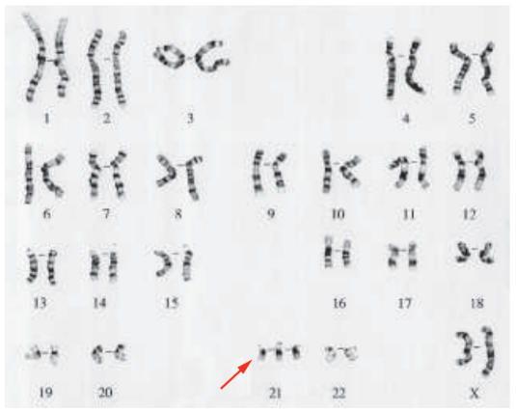In human, a large proportion of spontaneously aborted fetuses demonstrate some form of chromosomal imbalance; normal embryonic development requires a normal diploid complement.

The only human autosomal trisomy not associated to early lethality is trisomy 21, resulting in Down syndrome. As one of the shortest human autosomes, chromosome 21 contains only about 1.5% of the DNA in the human genome. Although there is considerable phenotypic variation among down syndrome individuals, traits such as intellectual disabilities, a weak muscle tone (hyponia) in infancy, and skeletal abnormalities are usually associated with the condition. Many Down syndrome babies die in their first year after birth from heart defects and increased susceptibility to infection. The large majority of cases derive from a non-disjunction error during female meiosis. Some people with Down syndrome have three copies of only part of, rather than the entire, chromosome 21. It is thus probable that genetic imbalance for only a few genes may be a sufficient cause of the condition.

Remember also the aneuploidies in the sex chromosome studied before – Klinefelter syndrome and Turner syndrome.

## structural variants (sv)

Structural variants: genomic rearrangement that alter relatively large segments of DNA.

Generally defined as a structure variation of a region of DNA of about 1 Kb or larger (to whole chromosome regions)

* submicroscopic SV (from 1 kb to ~ 3-5 Mb)
* 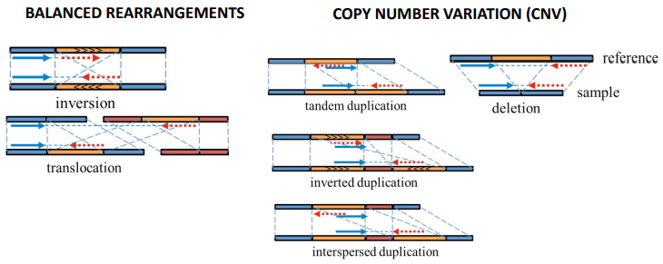microscopic SV (> 3-5 Mb) – visible with karyotype

It represents an important mutational source shaping genome evolution and function, and a significant contributor to diseases.

Main classes of SV:

* Insertions
* Deletions
* Inversions
* Translocations

And there are divided in two groups as represented in the picture.

The causes of structural variants may be:

* 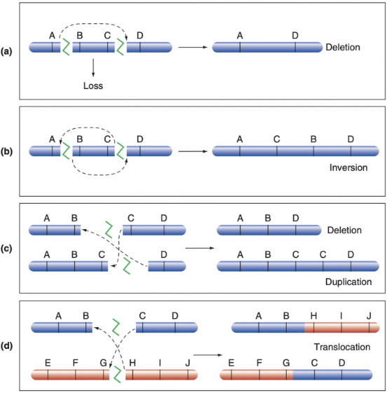Mistakes in repair of chromosome breaks

If a single chromosome suffers two double-strand breaks, loss of the fragment between the breaks followed by DNA repair that fuses the remaining broken ends results in a **deletion** (a).

If the intervening fragment instead is ligated back into the chromosome, but only after it rotates by 180°, an **inversion** is generated (b).

Breakage of two homologous chromosomes or sister chromatids at different location can result in a **deletion** and a **duplication** if the broken chromosome ends change places before they are brought together by DNA repair (c).

Finally, breakage of two nonhomologous chromosomes can result in a reciprocal **translocation** if the broken end switch places before repair and fusion (d).

* Incorrect meiotic crossover at repeated sequences – non allelic homologous recombination (NAHR)

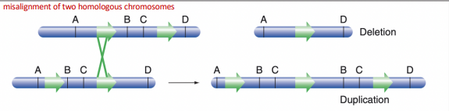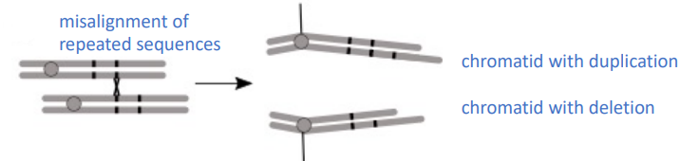A second cause of structural variance is when there are repeated sequences. Eukaryotic genomes have many repeated sequences, so consider that in the human genome more than 50% of the sequence is composed of repeated sequences, sequencies that are present many times and that have a high homology, a high grade of similarity. These sequences can promote errors of alignment during a meiotic pairing.

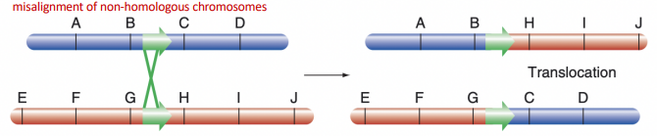On a chromosome there are these repeated sequences that help the alignment of the chromosome, but a sort of misalignment during meiotic paring may happen. Therefore, the repeated sequence may align with another pair instead of the normal one and then, if a crossing over then takes place with this misaligned chromosome, the result will be the formation of a deletion end the formation of a duplication.

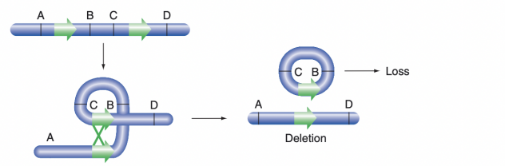Furthermore, it's possible that these repeated sequences are on nonhomologous chromosome. In this case the result will be a translocation.

It's possible also that these errors of alignment can take place within the same chromatid. So, crossovers between repeated sequences at two locations on the same chromosome can result in a deletion if the repeats are in the same direction.

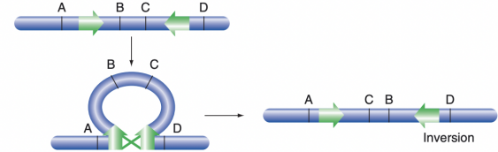

If the repeated sequences are in opposite orientation on the same chromatid the result will be an inversion.

The phenotypic consequences of CNVs depend on dimension, the type of genomic sequence involved, and the genes involved (dosage sensitive genes, essential genes…). If deletions have phenotypic effect, these are usually deleterious. Duplications are usually less deleterious than deletions.

CNVs have been shown to play crucial roles in the expression of many of our individual traits. They represent a substantial proportion of the total genetic variability within humans.

In many cases, CNVs are formed through nonallelic homologous recombination, facilitated by the presence in the human genome of repetitive DNA elements, **low copy repeats**, that cause chromosomes to misalign during recombination.